**MongoDB Assignment 2**

1. Create a database named university and a collection named students. Insert multiple student documents with fields: name, age, department, and grades.

Creating database and collection

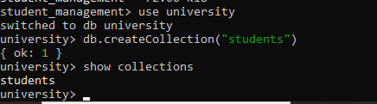

Data insertion

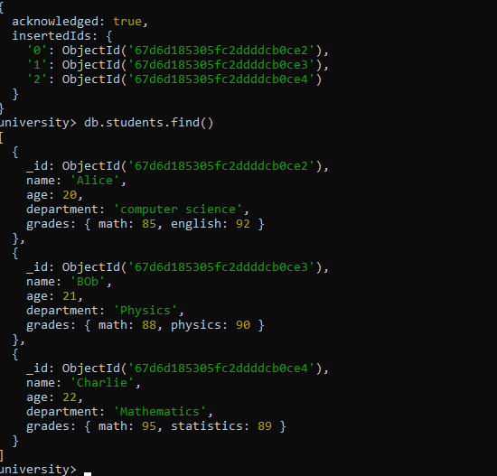

1. Write a query to display all students who are in the Computer Science department.

db.students.find({department:"computer science"})

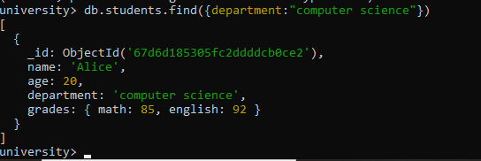

1. Write a query to update the grades of a student named Alice by adding a new subject programming with a grade of 93.

db.students.updateOne(

{ name: "Alice" },

{ $set: { "grades.Programming": 93 } }

);

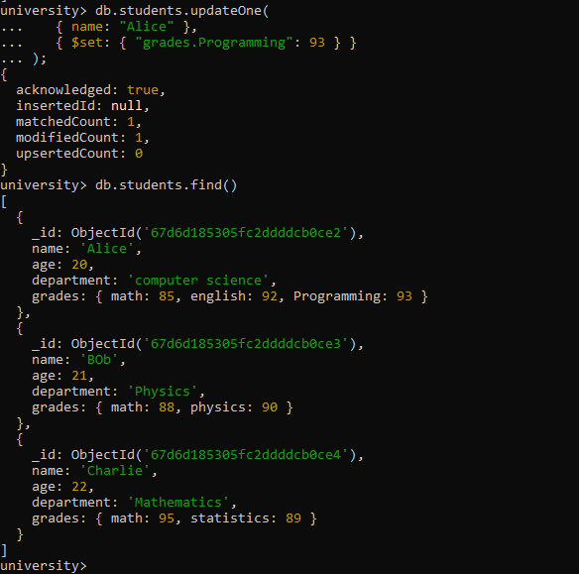

1. Write a query to increment the age of all students by 1.

db.students.updateMany({},{$inc:{age:1}})

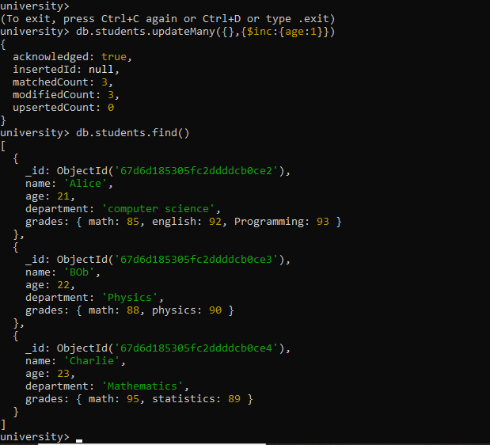

1. Write a query to delete all students who are 23 years old.

db.students.deleteMany({age:23})

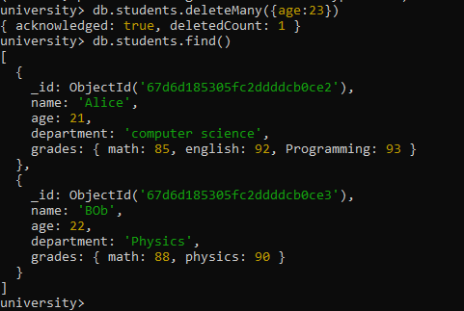

1. Write a query to create an index on the name field of the students collection.

db.students.createIndex({ name: 1 });

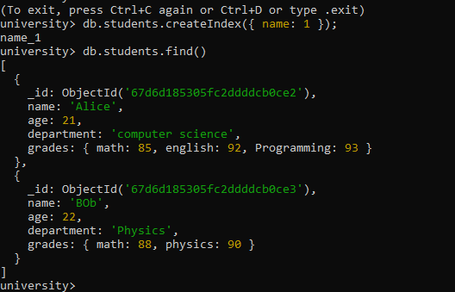

1. Write an aggregation query to group students by their department and calculate the average age in each department.

db.students.aggregate([

{

$group: {

_id: "$department",

averageAge: { $avg: "$age" }

}}]);

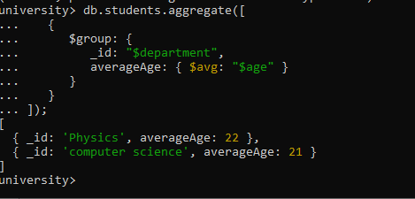

1. Write a query to find all students who have scored more than 90 in any subject.

db.students.find({

$expr: {

$gt: [

{ $max: { $objectToArray: "$grades" } },

90

]

}

});

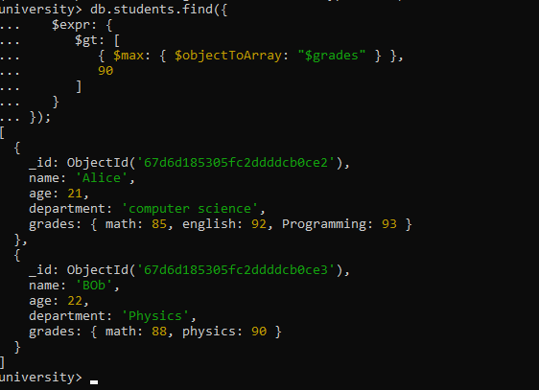

1. Write a query to add a new field graduated set to false for all students who are in the Mathematics department.

db.students.updateMany(

{ department: "math" },

{ $set: { graduated: false } }

);

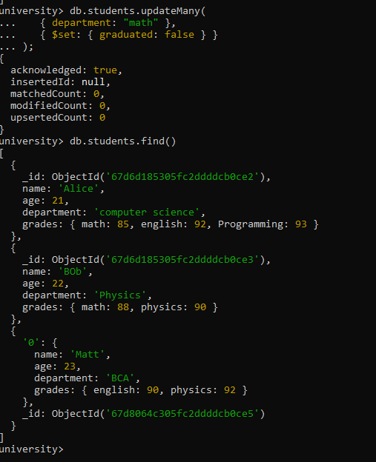

db.students.updateMany(

{ department: "Mathematics" },

{ $set: { graduated: false } }

);

1. How can you retrieve only the name and department fields for all students, excluding the _id field?

db.students.find(

{},

{ name: 1, department: 1, _id: 0 });

